**Ideation Phase**

# Brainstorm & Idea Prioritization Template

|  |  |
| --- | --- |
| Date | 19 September 2022 |
| Team ID | PNT2022TMID44982 |
| Project Name | Personal Assistance For Seniors And Who are Reliant |
| Maximum Marks | 4 Marks |

**Step-1: Team Gathering, Collaboration and Select the Problem Statement**

**1:**

**DEFINE PROBLEM STATEMENT:**

A medicine reminder app designed for people who frequently forget to take their medications. You may also keep track of your appointments. Its parental feature distinguishes it from other apps on the market, allowing you to keep track of and remotely assist your loved ones who find it difficult to utilize such an app with their reminders.

**Step-2: Brainstorm, Idea Listing and Grouping**

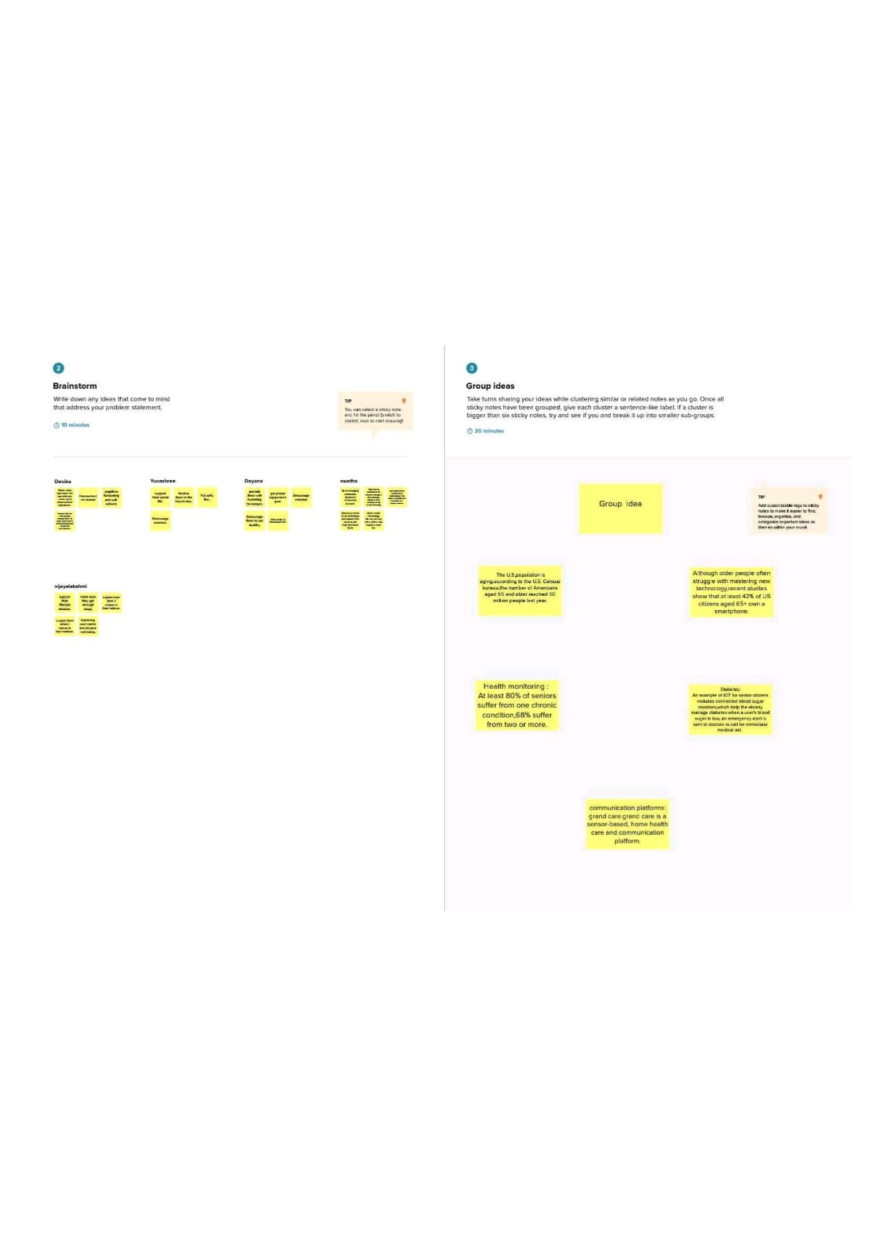dayana
**2:BRAINSTORM**

# 3:GROUP IDEAS

**>It should be implemented in smart watches or other wearable devices.**

**>Set medication reminders once and it should be up to date.**

**>Medicine name,Strength,dose should be displayed.**

**>It should operated in offline mode also**

**>Application should alert to refill the medicine**

**Step-3: Idea Prioritization**

## 4 : Prioritize

